Installing and Setting Up Docker in the EC2 instance Ubuntu Server

Login AWS console and Create an EC2 Instance
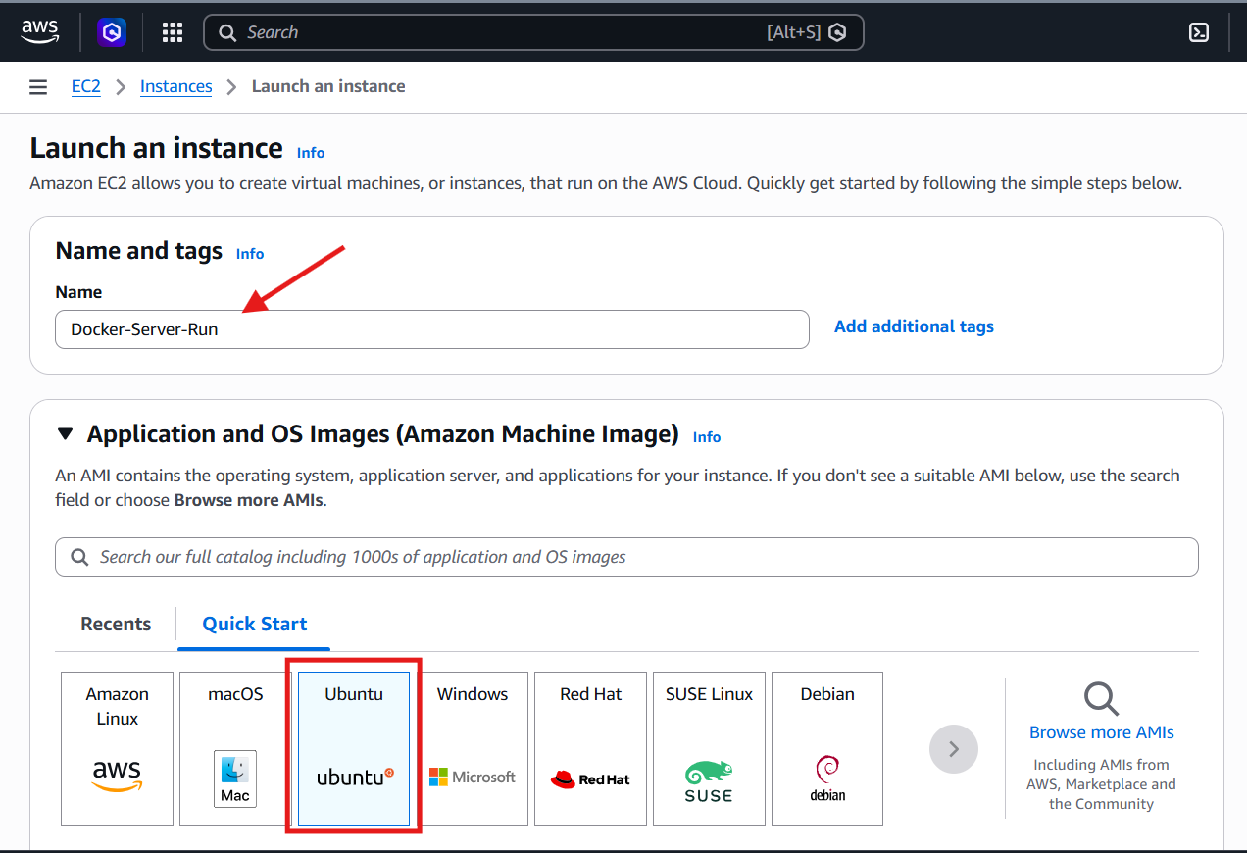
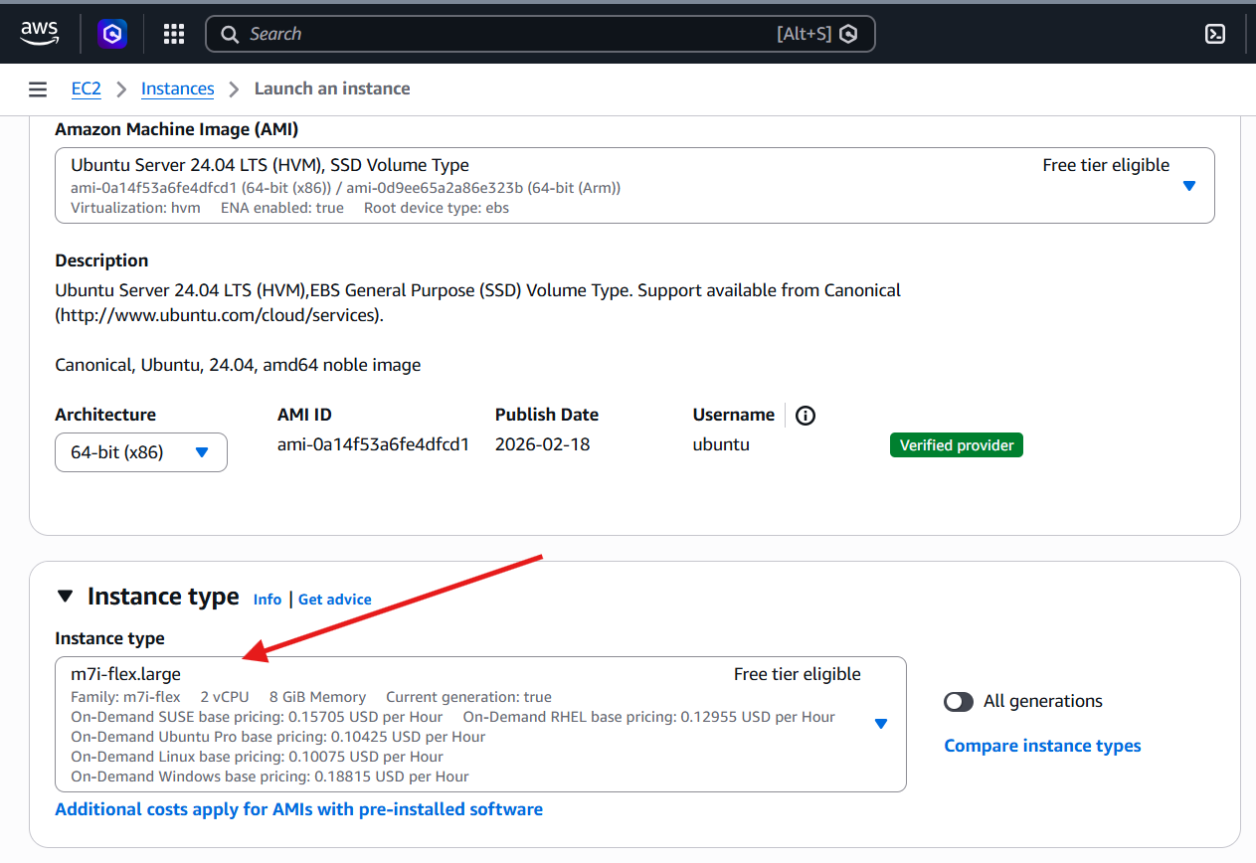
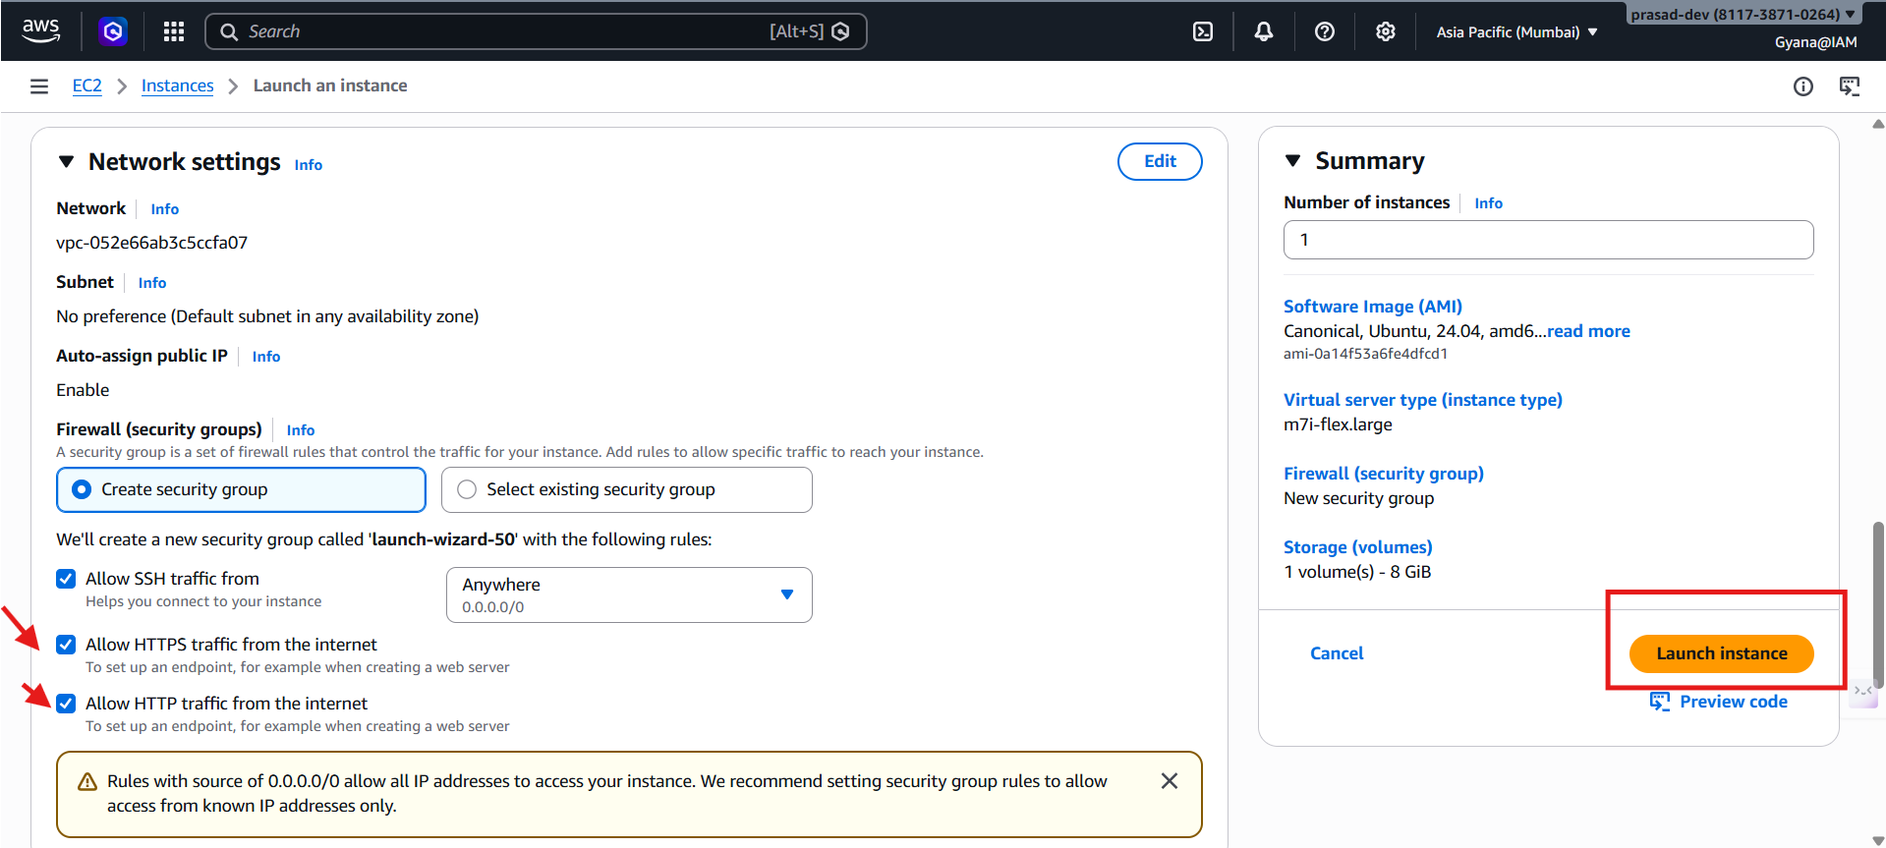
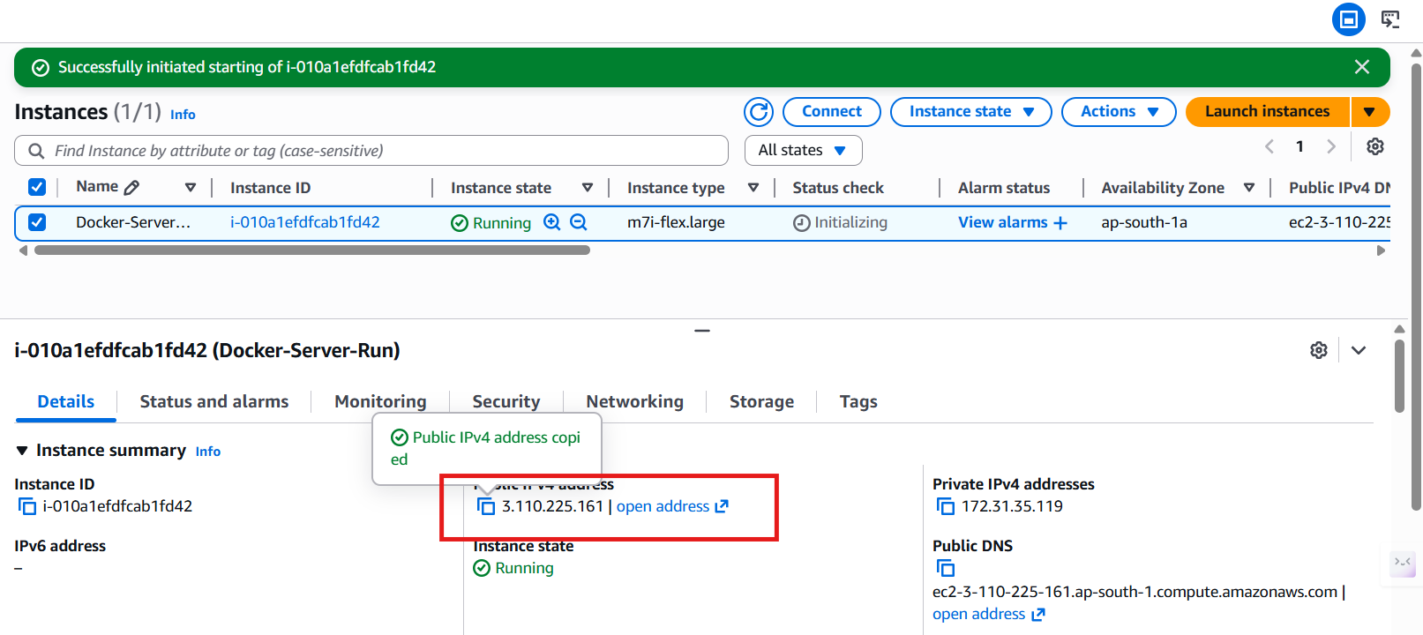
- Connect the EC2 instance using the Mobaxterm.
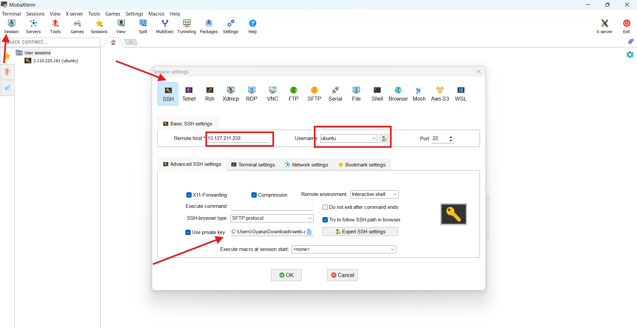
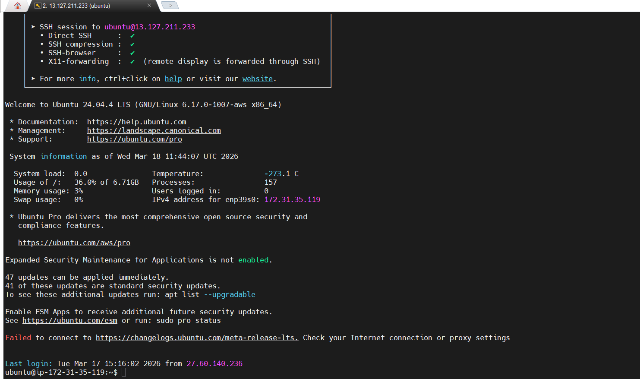

Setting up the docker apt repository
# Add Docker's official GPG key:
sudo apt update
sudo apt install ca-certificates curl
sudo install -m 0755 -d /etc/apt/keyrings
sudo curl -fsSL https://download.docker.com/linux/ubuntu/gpg -o /etc/apt/keyrings/docker.asc
sudo chmod a+r /etc/apt/keyrings/docker.asc

# Add the repository to Apt sources:
sudo tee /etc/apt/sources.list.d/docker.sources <<EOF
Types: deb
URIs: https://download.docker.com/linux/ubuntu
Suites: $(. /etc/os-release && echo "${UBUNTU_CODENAME:-$VERSION_CODENAME}")
Components: stable
Signed-By: /etc/apt/keyrings/docker.asc
EOF
sudo apt update
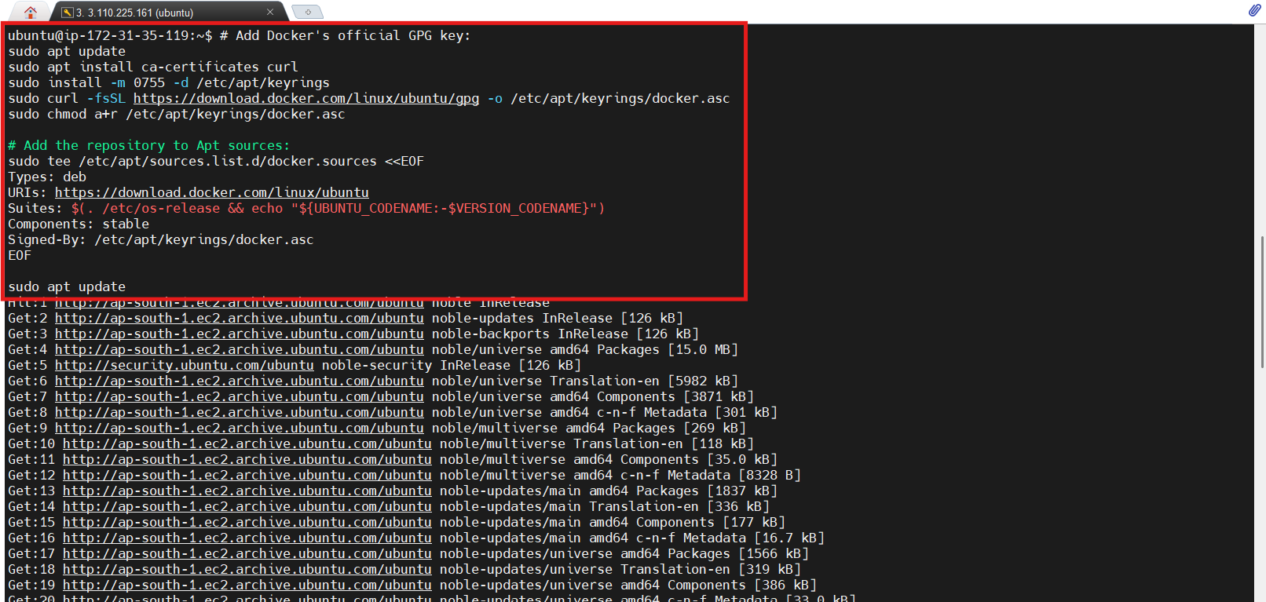
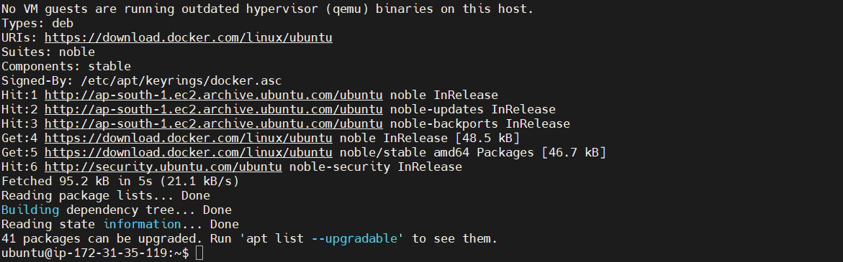

Install Latest version of Docker
sudo apt install docker-ce docker-ce-cli containerd.io docker-buildx-plugin docker-compose-plugin

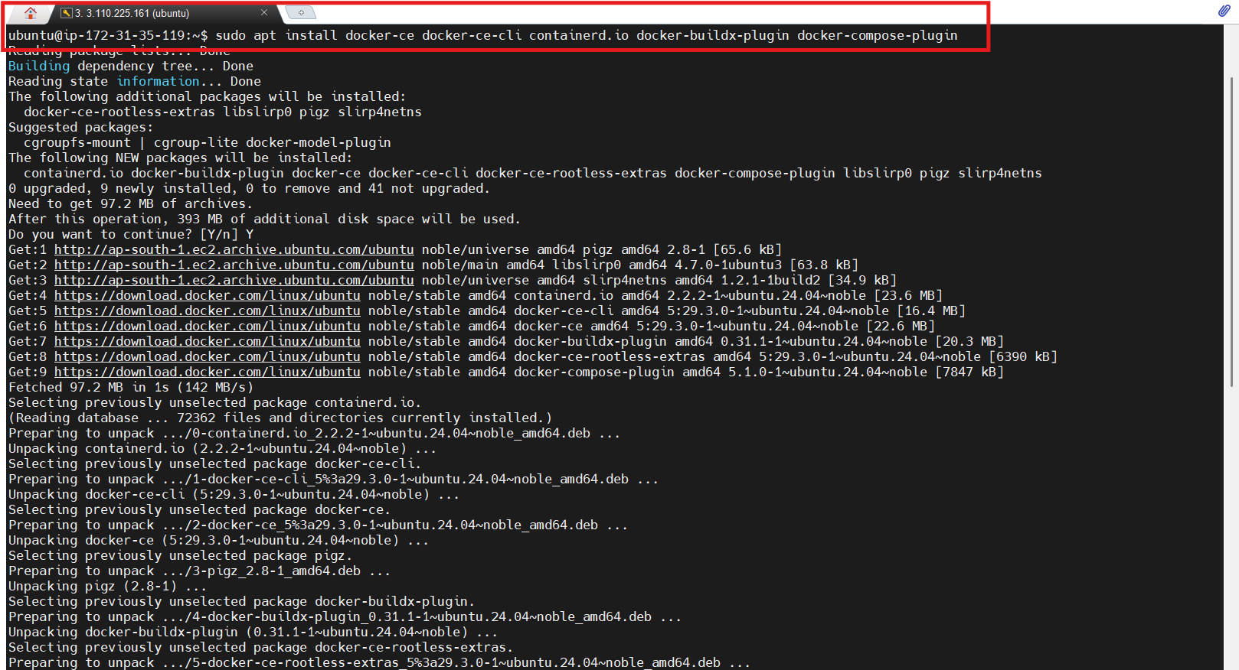
Verify the docker is running
- sudo systemctl status docker
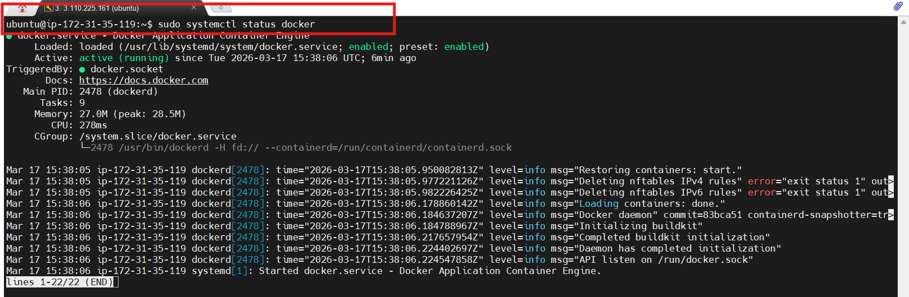
Check the Docker Version
- docker -v
- docker --version
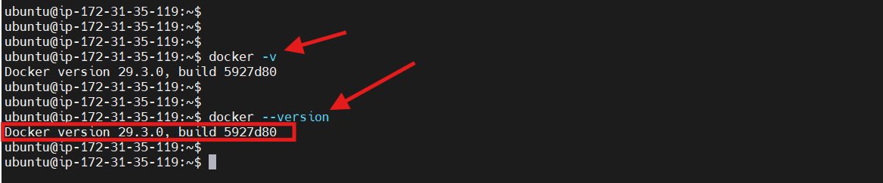

Check the Docker Images
- sudo docker images
- sudo docker image ls
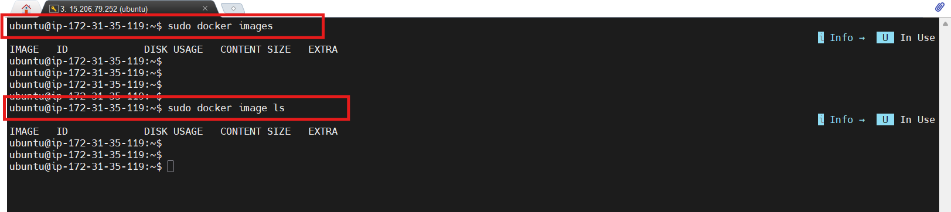
As images are not available in this docker so I will pull the images from Docker Hub.
Docker Hub is the storing area of images where we store our Images or Some images provided by docker are stored like Git Hub.

Pull the image from Docker Hub
- docker pull image-name
- docker pull hello-world (hello-world is a image)
- docker pull nginx:stable (stable is the version of nginx)
Note:
If you don’t mention any version of a image while pulling it will directly pull the latest version.
If you are a root user you can directly pull the image using the docker pull image-name:version
If you are not a root user then you should use sudo before the command otherwise it will tell permission denied.

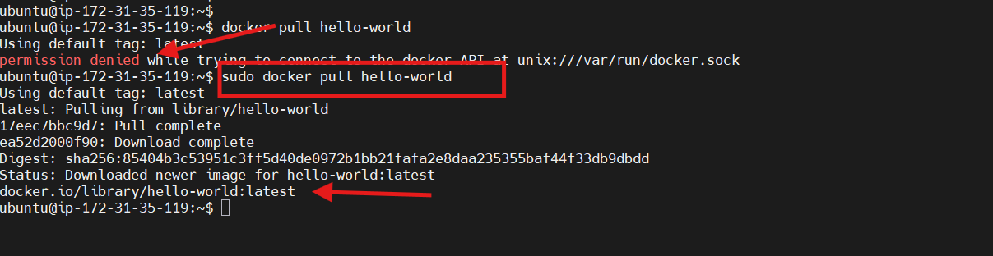
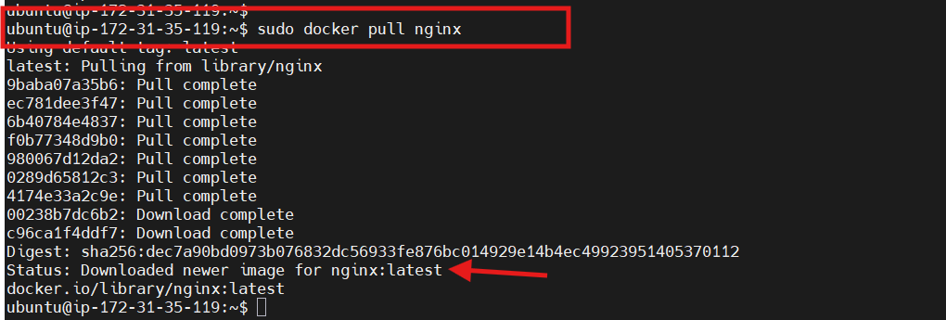
Check the images now
- sudo docker image ls (If you are not a root user use sudo)
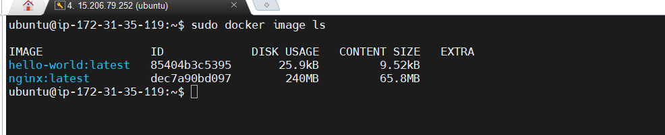

Form Image we can create containers
- docker ps (To check the containers)
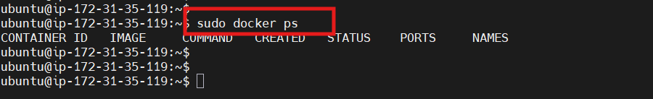
- Don’t have any containers yet so we will create one for the hello-world
Container Creation
- docker create image-name
- docker create hello-world:latest
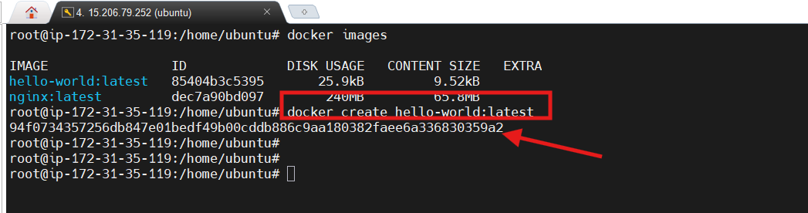
- docker create nginx:latest
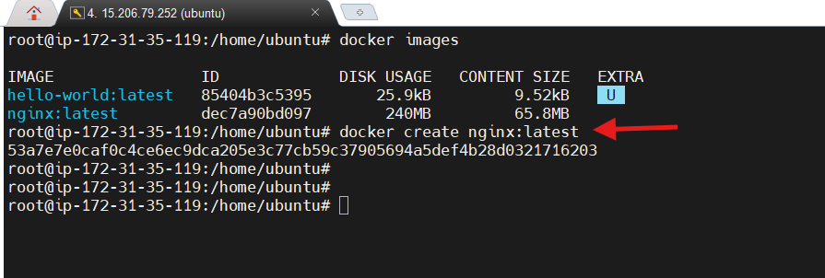
- Check the container is created or not
- docker ps -a (It will check all the container which is created and stoped also)
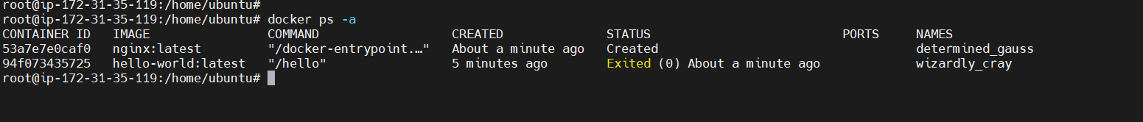

Start the container
- docker start docker-container-name/container-id
- docker start 53a7e7e0caf0(container id)
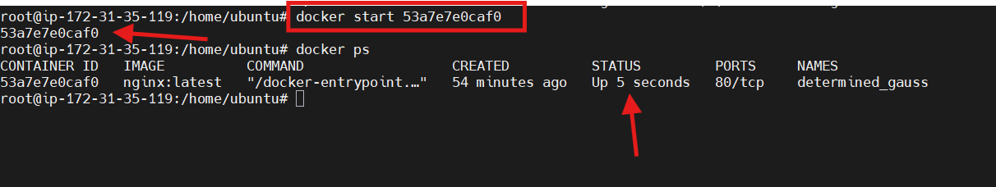

Stop the container
- docker stop container-id/container-name
